1.CREATING A FILE IN THE LOCAL DRIVE

package com.caltech.lockedmeproject;

import java.io.File;

import java.io.IOException;

import java.util.Scanner;

//create a file directory

public class FileCreate {

public static void main(String[] args) throws IOException{

String path= "C:\\Caltech\\";

Scanner sc=new Scanner(System.in);

System.out.println("enter the file name");

String filename=sc.next();

String finalpath=path+filename;

System.out.println(finalpath);

//create a file

File file=new File(finalpath);

boolean res=file.createNewFile();

if(res!=true) {

System.out.println("file is not created");

}

else {

System.out.println("file is created");

}

}

}

OUTPUT: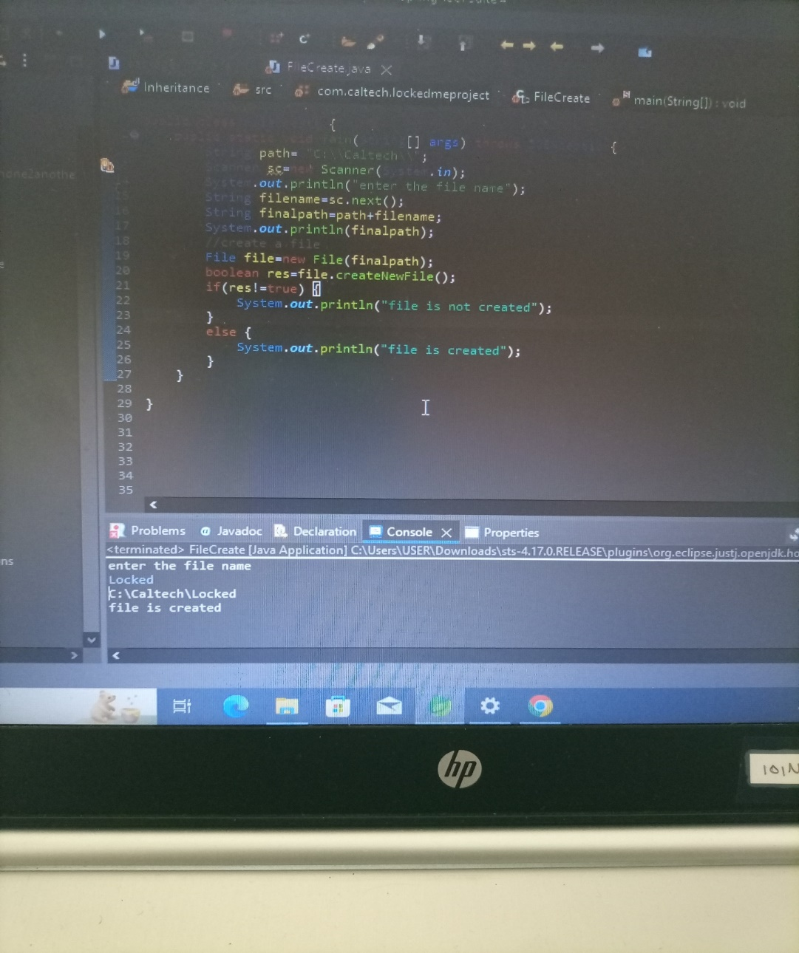

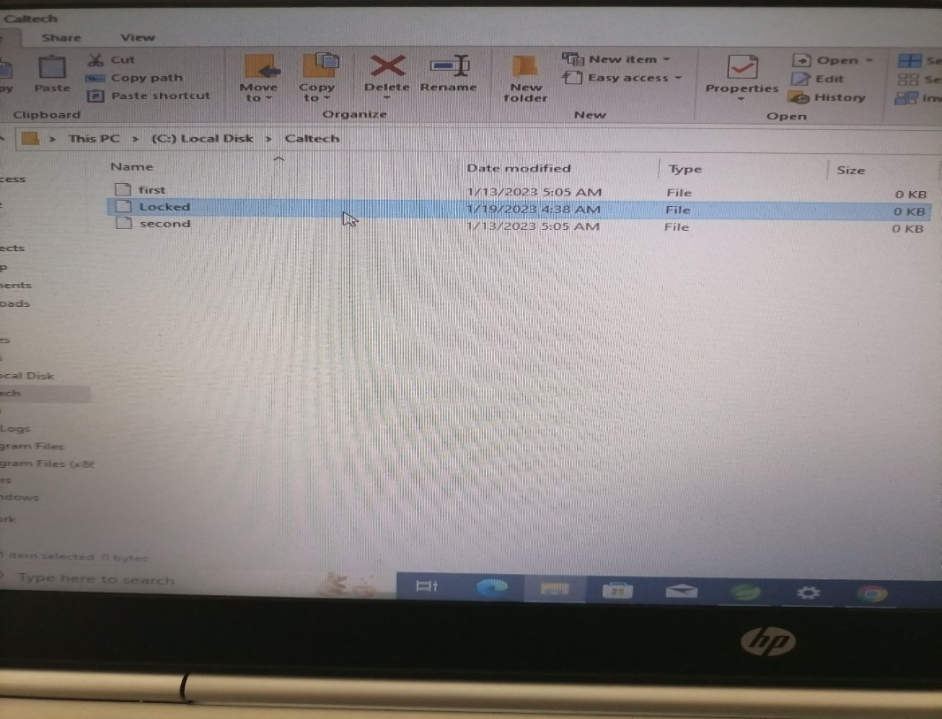

2.DELETING A FILE IN LOCAL DRIVE

package com.caltech.lockedmeproject;

import java.io.File;

import java.io.IOException;

import java.util.Scanner;

//Delete a file in directory or folder

public class FileDelete {

public static void main(String[] args) throws IOException{

String path= "C:\\Caltech\\";

Scanner sc=new Scanner(System.in);

System.out.println("enter the file name");

String filename=sc.next();

String finalpath=path+filename;

System.out.println(finalpath);

// delete operation

File file=new File(finalpath);

file.delete();

System.out.println("file gets deleted");

}

}

OUTPUT: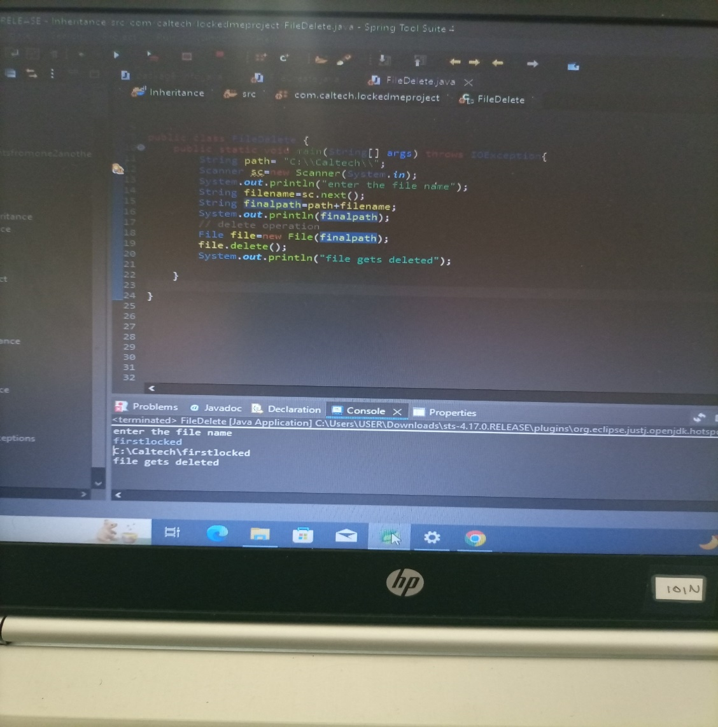

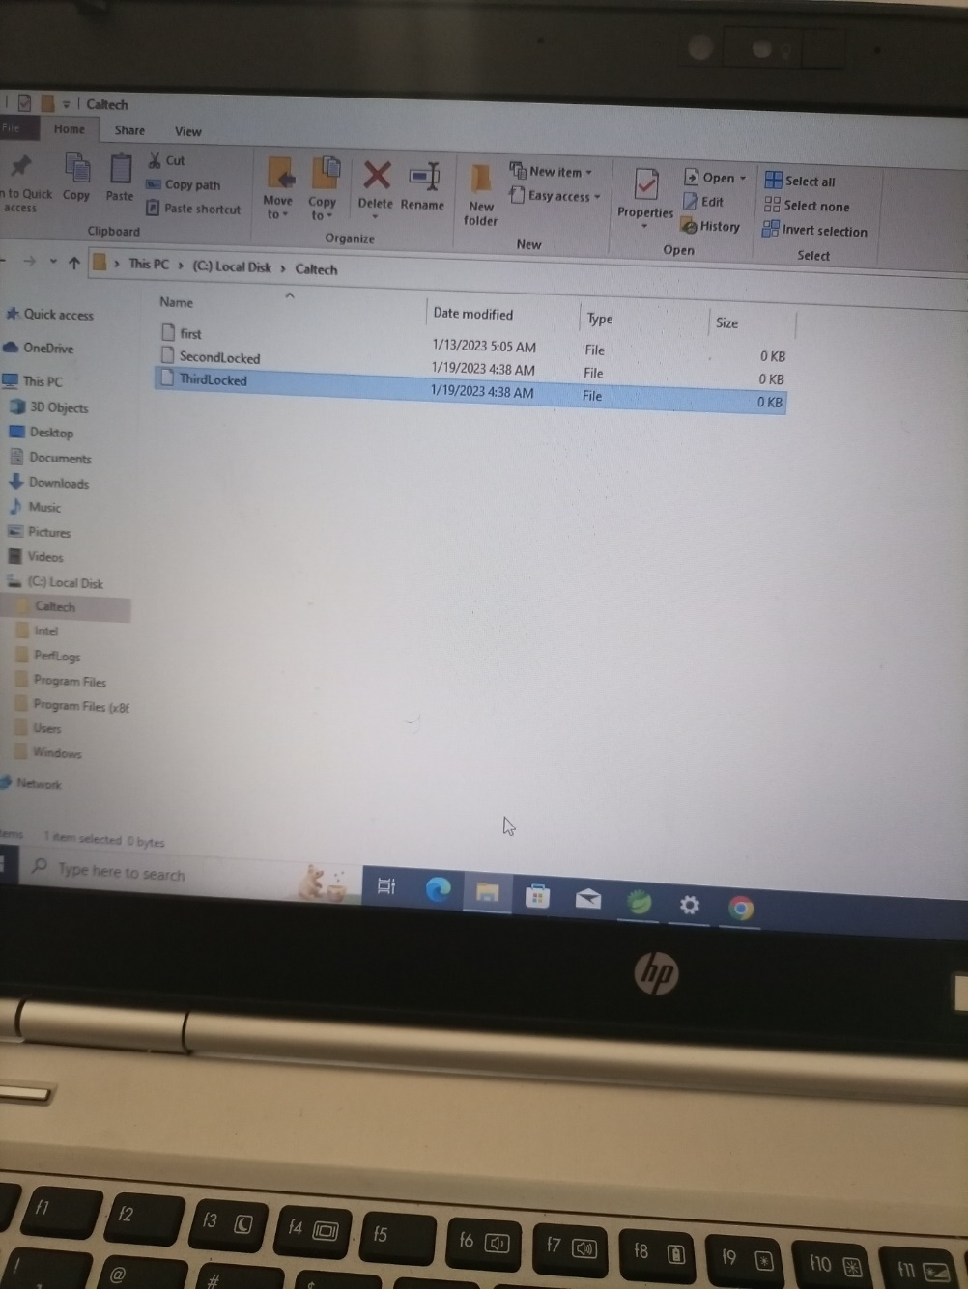

3.ARRANGING THE FILES IN ASCENDING ORDER IN THE DIRECTORY

package com.caltech.lockedmeproject;

import java.io.File;

import java.io.IOException;

import java.util.Scanner;

//Displaying files in ascending order in directory or folder

public class FileOrder {

public static void main(String[] args) throws IOException{

String path= "C:\\Caltech\\";

File file=new File(path);

//Display operation

File filename[]=file.listFiles();

//for-each loop

System.***out***.println("the list of files in ascending order in the "+ path + "is");

for(File ff:filename) {

System.***out***.println(ff.getName());

}

}}

OUTPUT: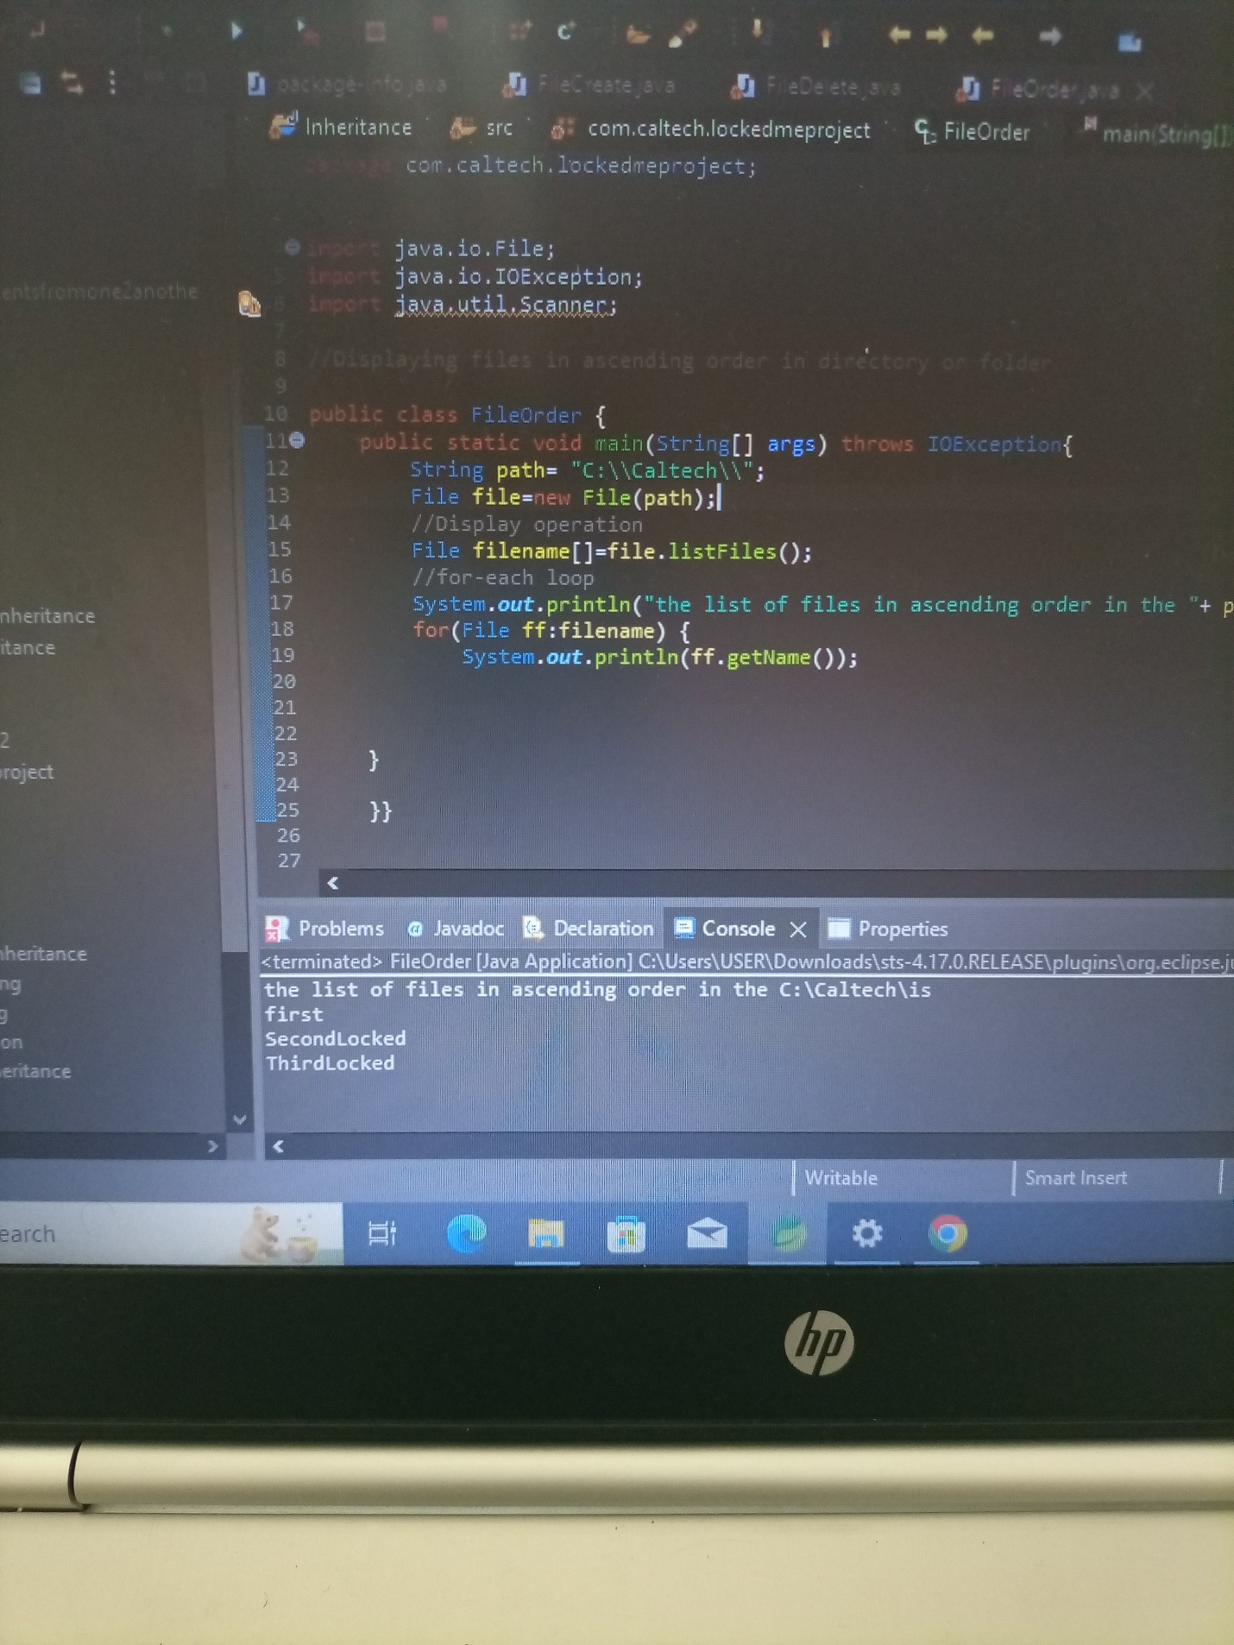

4.SEARCHING FOR THE FILE IN THE LOCAL DIRECTORY

package com.caltech.lockedmeproject;

import java.io.File;

import java.io.IOException;

import java.util.Scanner;

//Searching for files in directory or folder

public class FileSearch{

public static void main(String[] args) throws IOException{

String path= "C:\\Caltech\\";

Scanner sc=new Scanner(System.***in***);

System.***out***.println("enter the name of file to search");

String Filenamesearch=sc.next();

File file=new File(path);

//search operation

File filename[]=file.listFiles();

//for-each loop

int flag=0;

for(File ff:filename) {

if(ff.getName().equals(Filenamesearch)) {

flag=1;

break;

}

else {

flag=0;

}

}

if(flag==1) {

System.***out***.println("file is found");

}

else {

System.***out***.println("file is not found");

}

}

}

OUTPUT: 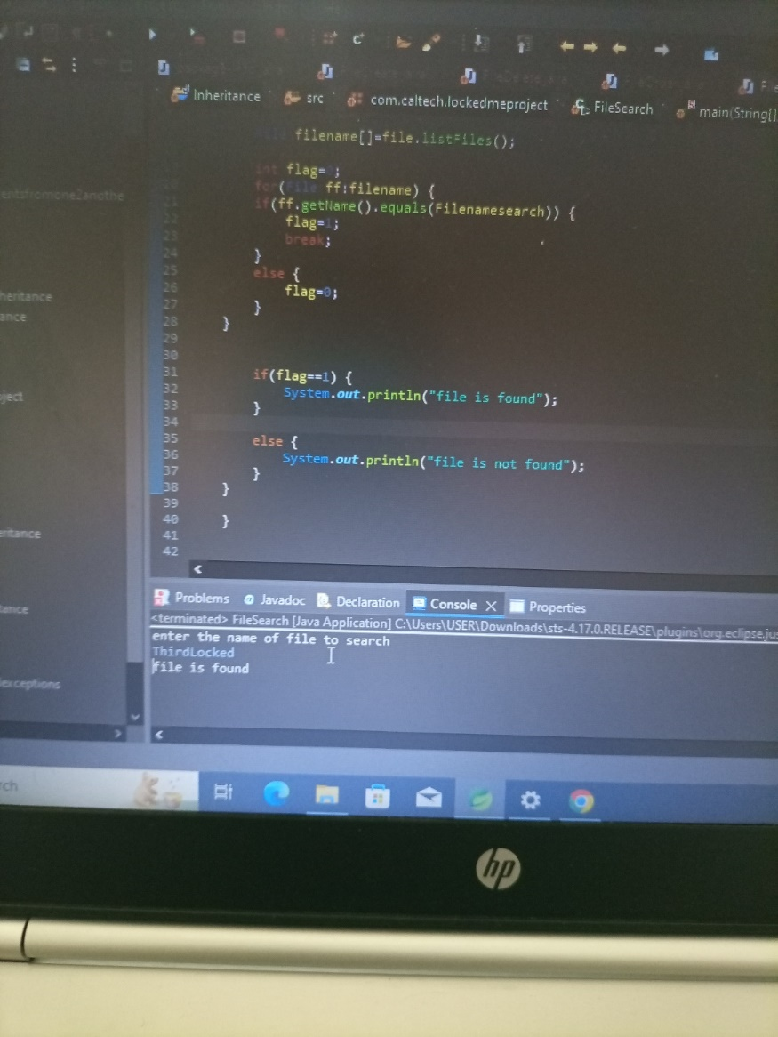

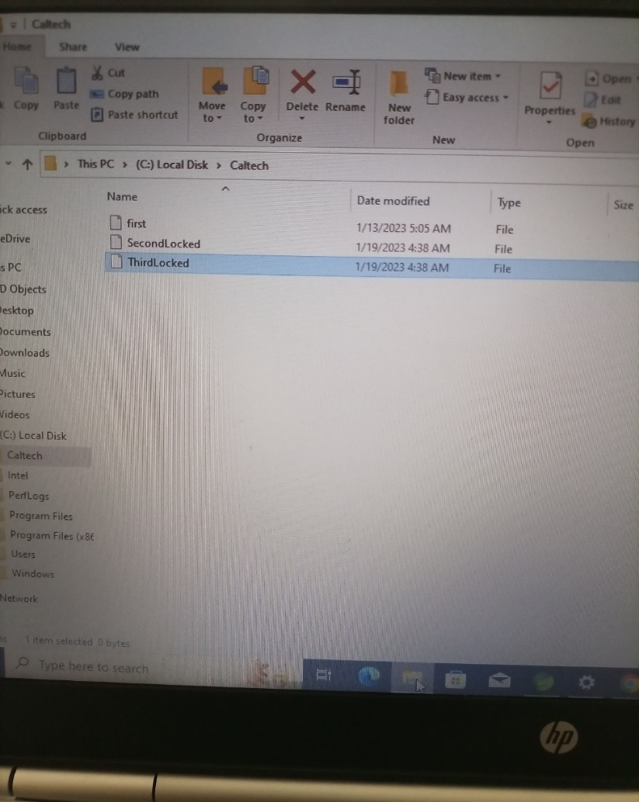

5.SWITCH OF THE PROGRAM

package com.caltech.lockedmeproject;

import java.io.File;

import java.io.IOException;

import java.util.Scanner;

public class SwitchCase{

public static void main(String[] args) {

while(true) {

Scanner sc=new Scanner(System.in);

System.out.println("menu 1.files arranged 2.file added 3.file deleted 4.file searched 5.exit");

System.out.println("enter your choice");

int ch=sc.nextInt();

int ch1=sc.nextInt();

switch(ch) {

case 1:

System.out.println("files arranged");

break;

case 2:

switch (ch1) {

case 2:

System.out.println("file added");

case 3:

System.out.println("file deleted");

case 4:

System.out.println("file searched");

case 5:

return;

}

break;

case 3:

System.exit(0);

}}}}

OUTPUT:

